**Lab Exercises**

**Classes and Object (Assignment 1)**

1. Create a class called Emp with data members empno, empname, designation, dept and salary and methods as readEmpData() (to read values to data members) and displayEmpData() (to display data members values to the screen) create an employee instance and display its information.

import java.util.Scanner; // Import the Scanner class for taking user input

public class Emp {

    int empno; // Variable to store employee number

    String empname; // Variable to store employee name

    String designation; // Variable to store employee designation

    String dept; // Variable to store employee department

    int salary; // Variable to store employee salary

    // Method to read employee data from user input

    public void readEmpData() {

        Scanner sc = new Scanner(System.in); // Create a Scanner object for input

        System.out.println("Enter Employee Number: ");

        empno = sc.nextInt(); // Read integer input for employee number

        // Consume the newline character left by nextInt()

        sc.nextLine();

        System.out.println("Enter Employee Name: ");

        empname = sc.next(); // Read string input for employee name

        System.out.println("Enter Designation: ");

        designation = sc.next(); // Read string input for employee designation

        System.out.println("Enter Department: ");

        dept = sc.next(); // Read string input for employee department

        System.out.println("Enter Salary: ");

        salary = sc.nextInt(); // Read integer input for employee salary

        sc.close(); // Close the Scanner object to prevent resource leaks

    }

    // Method to display employee data

    public void displayEmpData() {

        System.out.println("Employee Number: " + empno); // Display employee number

        System.out.println("Employee Name: " + empname); // Display employee name

        System.out.println("Designation: " + designation); // Display employee designation

        System.out.println("Department: " + dept); // Display employee department

        System.out.println("Salary: " + salary); // Display employee salary

    }

}

    // Method to display employee data

    public void displayEmpData() {

        System.out.println("Employee Number: " + empno); // Display employee number

        System.out.println("Employee Name: " + empname); // Display employee name

        System.out.println("Designation: " + designation); // Display employee designation

        System.out.println("Department: " + dept); // Display employee department

        System.out.println("Salary: " + salary); // Display employee salary

    }

}

public class TestEmp {

    public static void main(String[] args) {

        // Create an instance of the Emp class

        Emp employee = new Emp();

        // Call the method to read employee data from user input

        employee.readEmpData();

        // Call the method to display the employee data

        employee.displayEmpData();

    }

}

Output

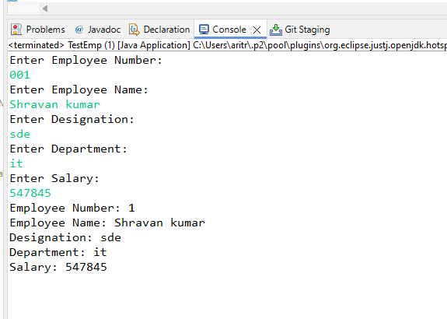

1. Create a class Electricity bill with data members as customer number, customer name, units consumed and methods as follows:

1. readData() - to read the values of data members.

2. showData - to display the customer details

3. computeBill() - to calculate and return electricity charges to be paid. calculate the bill as specified below

number of units charges

< = 100 Rs.1.20

for the next 200 units Rs. 2.00

for the next 300 units Rs. 3.00

for more Rs. 5.00

ex: input = 320 units output = 100*1.20 +200*2.00+20*3.00 = Rs. 580

Read customer object values, calculate electricity bill and display the values.

import java.util.Scanner; // Import the Scanner class for taking user input

public class ElectricityBill {

    int customerNumber; // Variable to store customer number

    String customerName; // Variable to store customer name

    int unitsConsumed; // Variable to store the number of units consumed

    // Method to read customer data from user input

    public void readData() {

        Scanner s = new Scanner(System.in); // Create a Scanner object for input

        // Prompt and read customer number

        System.out.println("Enter Customer Number: ");

        customerNumber = s.nextInt();

        // Consume the newline character left by nextInt()

        s.nextLine();

        // Prompt and read customer name

        System.out.println("Enter Customer Name: ");

        customerName = s.nextLine();

        // Prompt and read the number of units consumed

        System.out.println("Enter the number of units you have consumed: ");

        unitsConsumed = s.nextInt();

        // Close the Scanner object to prevent resource leaks

        s.close();

    }

    // Method to display customer data

    public void showData() {

        // Display customer number

        System.out.println("Customer Number: " + customerNumber);

        // Display customer name

        System.out.println("Customer Name: " + customerName);

        // Display the number of units consumed

        System.out.println("Units Consumed: " + unitsConsumed);

    }

    // Method to compute the electricity bill based on units consumed

    public double computeBill() {

        double bill; // Variable to store the computed bill amount

        // Calculate the bill amount based on different slabs

        if (unitsConsumed <= 100) {

            bill = unitsConsumed * 1.20; // First 100 units at $1.20 per unit

        } else if (unitsConsumed <= 300) {

            bill = 100 * 1.20 + (unitsConsumed - 100) * 2.00; // Next 200 units at $2.00 per unit

        } else if (unitsConsumed <= 600) {

            bill = (100 * 1.20) + (200 * 2.00) + (unitsConsumed - 300) * 3.00; // Next 300 units at $3.00 per unit

        } else {

            bill = (100 * 1.20) + (200 * 2.00) + (300 * 3.00) + (unitsConsumed - 600) * 5.00; // Above 600 units at $5.00 per unit

        }

        // Return the computed bill amount

        return bill;

    }

}

public class ElectricityBillMain {

    public static void main(String[] args) {

        // Create an instance of the ElectricityBill class

        ElectricityBill eb = new ElectricityBill();

        // Call the method to read customer data from user input

        eb.readData();

        // Call the method to display customer data

        eb.showData();

        // Call the method to compute the electricity bill and store the result

        double bill = eb.computeBill();

        // Display the computed electricity bill

        System.out.println("Your Electricity Bill: " + bill);

    }

}

**Output**

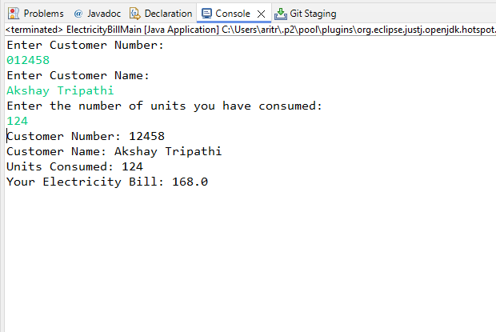

3. Write a Java program to create Student class with member variable as id, name, mark and result. Use method to initialize the value of name, id and marks. Write a member function to find the result and display the student details with result.

import java.util.Scanner;  // Import the Scanner class for taking user input

public class Student {

    static int id;  // Static variable to store student ID

    static String name;  // Static variable to store student name

    static int mark;  // Static variable to store student mark

    String result;  // Instance variable to store result (Pass/Fail)

    // Method to read student details from user input

    public void readDetails() {

        Scanner sc = new Scanner(System.in);  // Create a Scanner object for input

        // Prompt and read student ID

        System.out.println("Enter Student's Id: ");

        id = sc.nextInt();

        // Consume the newline character left by nextInt()

        sc.nextLine();

        // Prompt and read student name

        System.out.println("Enter Student's Name: ");

        name = sc.nextLine();

        // Prompt and read student marks

        System.out.println("Enter Student's Marks: ");

        mark = sc.nextInt();

        // Close the Scanner object to prevent resource leaks

        sc.close();

    }

    // Method to determine the result based on marks

    public void checkResult() {

        if (mark > 50) {

            result = "Pass";  // Assign "Pass" if marks are greater than 50

        } else {

            result = "Fail";  // Assign "Fail" if marks are 50 or less

        }

    }

    // Method to display student details and result

    public void dispDetails() {

        System.out.println("Student's Id: " + id);  // Display student ID

        System.out.println("Student's Name: " + name);  // Display student name

        System.out.println("Student's Mark: " + mark);  // Display student marks

        System.out.println("Student's Result: " + result);  // Display student result

    }

}

public class StudentMain {

    public static void main(String[] args) {

        // Create an instance of the Student class

        Student s1 = new Student();

        // Call the method to read student details from user input

        s1.readDetails();

        // Call the method to determine the student's result based on marks

        s1.checkResult();

        // Call the method to display student details and result

        s1.dispDetails();

    }

}

**Output**

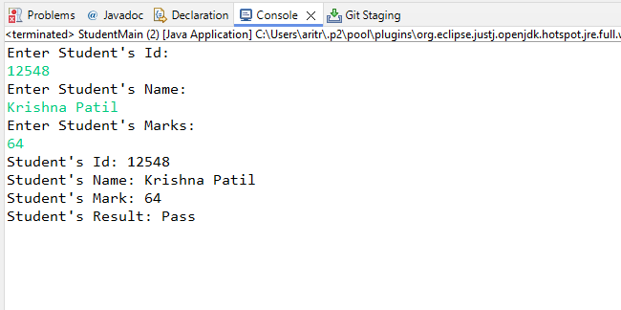

4. Write a Java program that creates a account class with instance variable accno, accname, amount and instance method withdraw, deposit, and interest. Create object of account class test all methods.

public class Account {

    int accNo;  // Variable to store account number

    String accName;  // Variable to store account holder's name

    double amount;  // Variable to store account balance

    // Constructor to initialize the account details

    public Account(int accNo, String accName, double amount) {

        this.accNo = accNo;  // Initialize account number

        this.accName = accName;  // Initialize account holder's name

        this.amount = amount;  // Initialize account balance

    }

    // Method to withdraw an amount from the account

    public void withdraw(double withdrawAmount) {

        // Check if the withdraw amount is valid and sufficient balance is available

        if (withdrawAmount > 0 && withdrawAmount <= amount) {

            amount -= withdrawAmount;  // Deduct the withdraw amount from the balance

            System.out.println("Withdrawal Successful. Remaining Balance: Rs. " + amount);

        } else {

            // Print an error message if the withdraw amount is invalid or insufficient balance

            System.out.println("Withdrawal failed! Insufficient Balance.");

        }

    }

    // Method to deposit an amount into the account

    public void deposit(double depositAmount) {

        // Check if the deposit amount is valid

        if (depositAmount > 0) {

            amount += depositAmount;  // Add the deposit amount to the balance

            System.out.println(depositAmount + " Deposited Successfully! Updated Balance: Rs. " + amount);

        } else {

            // Print an error message if the deposit amount is invalid

            System.out.println("Invalid Amount.");

        }

    }

    // Method to calculate the interest earned on the account balance

    public void calculateInterest(double rate) {

        double interest = (amount * rate) / 100;  // Calculate interest based on the rate

        System.out.println("Interest Earned: " + interest);  // Print the interest earned

    }

}

import java.util.Scanner;  // Import the Scanner class for taking user input

public class BankMain {

    public static void main(String[] args) {

        // Create a Scanner object for input

        Scanner s = new Scanner(System.in);

        // Creating an Account object with initial details

        Account a = new Account(154824, "Aritra", 25000);

        // Prompt and read the amount to withdraw

        System.out.println("Enter Withdrawal amount: Rs. ");

        double withdrawAmount = s.nextDouble();

        // Call the withdraw method to process the withdrawal

        a.withdraw(withdrawAmount);

        // Prompt and read the amount to deposit

        System.out.println("Enter Deposit amount: Rs. ");

        double depositAmount = s.nextDouble();

        // Call the deposit method to process the deposit

        a.deposit(depositAmount);

        // Prompt and read the interest rate

        System.out.println("Enter the rate (%): ");

        double rate = s.nextDouble();

        // Call the calculateInterest method to compute the interest

        a.calculateInterest(rate);

        // Close the Scanner object to prevent resource leaks

        s.close();

    }

}

**Output**

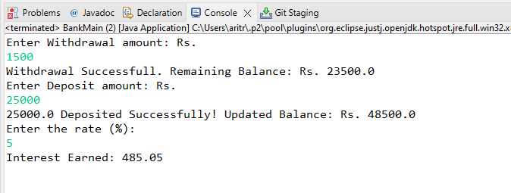

5. Write a Java program to create a class called player with name, age, country Name, total run as instance member. Create 5 player objects and write instance method to display the details of Player having more than 5000 as total run

import java.util.Scanner;  // Import the Scanner class for taking user input

public class Player {

    String name;  // Variable to store player's name

    int age;  // Variable to store player's age

    String countryName;  // Variable to store player's country name

    int totalRun;  // Variable to store player's total runs

    // Method to read player details from user input

    public void readDetails() {

        Scanner s = new Scanner(System.in);  // Create a Scanner object for input

        // Prompt and read player's name

        System.out.println("Enter Player's Name: ");

        name = s.nextLine();

        // Prompt and read player's age

        System.out.println("Enter Player's Age: ");

        age = s.nextInt();

        s.nextLine();  // Consume the newline character left by nextInt()

        // Prompt and read player's country name

        System.out.println("Enter Player's Country Name: ");

        countryName = s.nextLine();

        // Prompt and read player's total runs

        System.out.println("Enter Player's Total Run: ");

        totalRun = s.nextInt();

        s.nextLine();  // Consume the newline character left by nextInt()

    }

    // Method to check if the player's total runs exceed 5000

    public void checkRun() {

        if (totalRun > 5000) {

            dispPlayer();  // Call dispPlayer() method to display player details if total runs exceed 5000

        }

    }

    // Method to display player details

    public void dispPlayer() {

        System.out.println("Player's Name: " + name);  // Display player's name

        System.out.println("Player's Age: " + age);  // Display player's age

        System.out.println("Player's Country Name: " + countryName);  // Display player's country name

        System.out.println("Player's Total Run: " + totalRun);  // Display player's total runs

    }

}

public class PlayerMain {

    public static void main(String[] args) {

        // Create instances of the Player class

        Player p1 = new Player();

        Player p2 = new Player();

        Player p3 = new Player();

        Player p4 = new Player();

        Player p5 = new Player();

        // Read details for each player

        p1.readDetails();

        p2.readDetails();

        p3.readDetails();

        p4.readDetails();

        p5.readDetails();

        // Check runs and display details if applicable for each player

        p1.checkRun();

        p2.checkRun();

        p3.checkRun();

        p4.checkRun();

        p5.checkRun();

    }

}

**Output**

Enter Player's Name:

Virat Kohli

Enter Player's Age:

35

Enter Player's Country Name:

India

Enter Player's Total Run:

8,848

Enter Player's Name:

Rohit Sharma

Enter Player's Age:

37

Enter Player's Country Name:

India

Enter Player's Total Run:

10,709

Enter Player's Name:

Chris Gayle

Enter Player's Age:

44

Enter Player's Country Name:

West Indies

Enter Player's Total Run:

10480

Enter Player's Name:

AB de Villiers

Enter Player's Age:

40

Enter Player's Country Name:

South Africa

Enter Player's Total Run:

9577

Enter Player's Name:

Shubman Gill

Enter Player's Age:

24

Enter Player's Country Name:

India

Enter Player's Total Run:

2271

Player's Name: Virat Kohli

Player's Age: 35

Player's Country Name: India

Enter Player's Total Run: 8848

Player's Name: Rohit Sharma

Player's Age: 37

Player's Country Name: India

Enter Player's Total Run: 10709

Player's Name: Chris Gayle

Player's Age: 44

Player's Country Name: West Indies

Enter Player's Total Run: 10480

Player's Name: AB de Villiers

Player's Age: 40

Player's Country Name: South Africa

Enter Player's Total Run: 9577

**Inheritance and Polymorphism (Assignment 2)**

### 1. Write java program to implement Inheritance with following example:

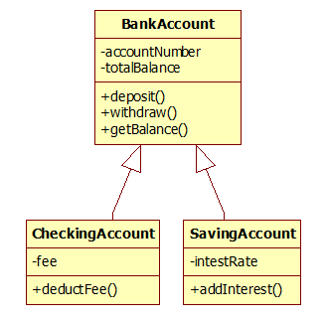

public class BankAccount {

    int accountNumber;  // Variable to store the account number

    double totalBalance;  // Variable to store the total balance

    // Constructor to initialize the account number and total balance

    public BankAccount(int accountNumber, double totalBalance) {

        this.accountNumber = accountNumber;  // Initialize account number

        this.totalBalance = totalBalance;  // Initialize total balance

    }

    // Method to deposit an amount into the account

    public double deposit(double depositAmount) {

        // Check if the deposit amount is greater than zero

        if (depositAmount > 0) {

            totalBalance += depositAmount;  // Add the deposit amount to the total balance

            System.out.println("Rs. " + depositAmount + " Deposited Successfully. Current Balance Rs. " + totalBalance);

        }

        return totalBalance;  // Return the updated balance

    }

    // Method to withdraw an amount from the account

    public double withdraw(double withdrawAmount) {

        // Check if the withdraw amount is greater than zero and does not exceed the total balance

        if (withdrawAmount > 0 && withdrawAmount <= totalBalance) {

            totalBalance -= withdrawAmount;  // Subtract the withdraw amount from the total balance

            System.out.println(withdrawAmount + " Withdrawn Successfully. Current Balance: " + totalBalance);

        } else {

            // Print an error message if the balance is insufficient

            System.out.println("Insufficient Balance.");

        }

        return totalBalance;  // Return the updated balance

    }

    // Method to get the current balance

    public void getBalance() {

        System.out.println("Your Current Balance is: " + totalBalance);  // Print the current balance

    }

}

public class CheckingAccount extends BankAccount {

    double fee; // Variable to store the fee

    // Constructor to initialize the checking account with account number, balance, and fee

    public CheckingAccount(int accountNumber, double totalBalance, double fee) {

        super(accountNumber, totalBalance); // Call the superclass constructor to initialize account number and balance

        this.fee = fee; // Initialize the fee

    }

    // Method to deduct the fee from the account balance

    public void deductFee(double fee) {

        totalBalance -= fee; // Subtract the fee from the total balance

        System.out.println("Total Balance after fees deduction: " + totalBalance); // Display the updated balance

    }

}

public class SavingsAccount extends BankAccount {

    double interestRate; // Variable to store the interest rate

    // Constructor to initialize the savings account with account number, balance, and interest rate

    public SavingsAccount(int accountNumber, double totalBalance, double interestRate) {

        super(accountNumber, totalBalance); // Call the superclass constructor to initialize account number and balance

        this.interestRate = interestRate; // Initialize the interest rate

    }

    // Method to add interest to the account balance

    public double addInterest(double interestRate) {

        // Calculate the total interest earned

        double totalInterest = (totalBalance * interestRate * 1) / 100;

        System.out.println("Interest earned: Rs. " + totalInterest); // Display the interest earned

        // Add the earned interest to the total balance

        totalBalance += totalInterest;

        // Return the updated balance

        return totalBalance;

    }

}

import java.util.Scanner; // Import the Scanner class for taking user input

public class BankMain {

    public static void main(String[] args) {

        int accNo = 0; // Variable to store account number

        double totalBalance; // Variable to store total balance

        double fees = 0; // Variable to store fees

        double interestRate = 0; // Variable to store interest rate

        Scanner s = new Scanner(System.in); // Create a Scanner object for input

        // Prompt and read account details

        System.out.println("Enter the Account Details Below: ");

        System.out.println("Enter Account Number: ");

        accNo = s.nextInt();

        System.out.println("Enter Total Balance: ");

        totalBalance = s.nextDouble();

        // Create a BankAccount object with the provided account number and balance

        BankAccount ba = new BankAccount(accNo, totalBalance);

        // Prompt and read deposit amount, then deposit it into the account

        System.out.println("Enter the amount you want to Deposit: ");

        double depositAmount = s.nextDouble();

        ba.deposit(depositAmount);

        // Prompt and read withdrawal amount, then withdraw it from the account

        System.out.println("Enter the amount you want to Withdraw: ");

        double withdrawAmount = s.nextDouble();

        ba.withdraw(withdrawAmount);

        // Prompt and read fees, then create a CheckingAccount object and deduct the fee

        System.out.println("Enter Fees: ");

        fees = s.nextDouble();

        CheckingAccount ca = new CheckingAccount(accNo, totalBalance, fees);

        ca.deductFee(fees);

        // Prompt and read interest rate, then create a SavingsAccount object and add interest

        System.out.println("Enter Interest Rate: ");

        interestRate = s.nextDouble();

        SavingsAccount sa = new SavingsAccount(accNo, totalBalance, interestRate);

        double interest = sa.addInterest(interestRate);

        // Calculate the total balance after all transactions

        totalBalance = totalBalance + depositAmount - withdrawAmount - fees + interest;

        // Display the current balance

        ba.getBalance();

        s.close(); // Close the Scanner object

    }

}

**Output**

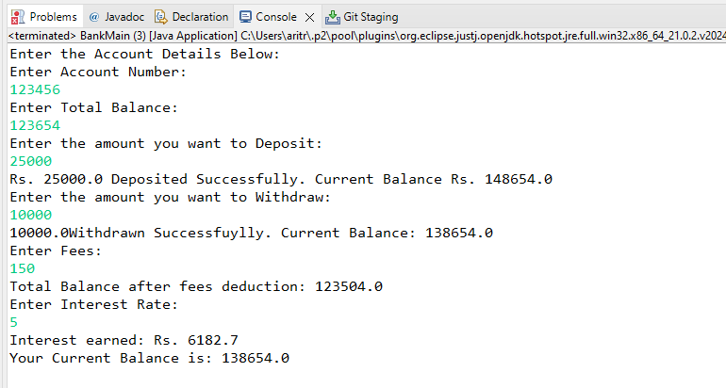

2. Write java program to implement Inheritance with following example: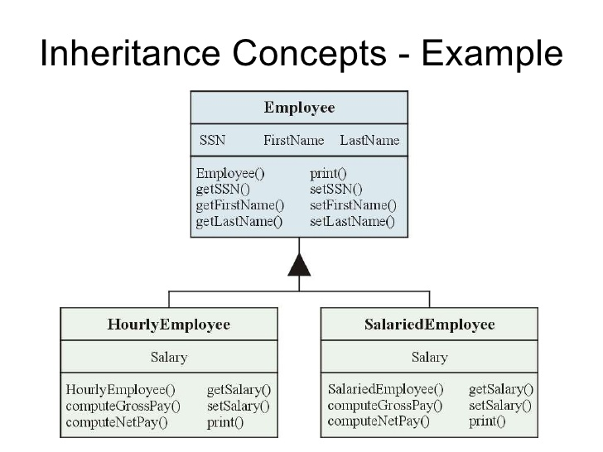

// Base class: Employee

public class Employee {

    // Private fields to store the employee's SSN, first name, and last name

    private String ssn;

    private String firstName;

    private String lastName;

    // Constructor to initialize the employee's SSN, first name, and last name

    public Employee(String ssn, String firstName, String lastName) {

        this.ssn = ssn;

        this.firstName = firstName;

        this.lastName = lastName;

    }

    // Getter method for SSN

    public String getSSN() {

        return ssn;

    }

    // Setter method for SSN

    public void setSSN(String ssn) {

        this.ssn = ssn;

    }

    // Getter method for first name

    public String getFirstName() {

        return firstName;

    }

    // Setter method for first name

    public void setFirstName(String firstName) {

        this.firstName = firstName;

    }

    // Getter method for last name

    public String getLastName() {

        return lastName;

    }

    // Setter method for last name

    public void setLastName(String lastName) {

        this.lastName = lastName;

    }

    // Method to print the employee's information

    public void print() {

        // Print SSN

        System.out.println("SSN: " + ssn);

        // Print first name

        System.out.println("First Name: " + firstName);

        // Print last name

        System.out.println("Last Name: " + lastName);

    }

}

// Subclass: HourlyEmployee extends Employee

public class HourlyEmployee extends Employee {

    // Private field to store the hourly salary

    private double salary;

    // Constructor to initialize HourlyEmployee with ssn, firstName, lastName, and salary

    public HourlyEmployee(String ssn, String firstName, String lastName, double salary) {

        // Call the constructor of the superclass Employee

        super(ssn, firstName, lastName);

        // Initialize the salary field

        this.salary = salary;

    }

    // Getter method for salary

    public double getSalary() {

        return salary;

    }

    // Setter method for salary

    public void setSalary(double salary) {

        this.salary = salary;

    }

    // Method to compute the gross pay based on hours worked

    public double computeGrossPay(int hoursWorked) {

        return salary * hoursWorked;

    }

    // Method to compute the net pay (in this example, it's the same as gross pay)

    public double computeNetPay(int hoursWorked) {

        return computeGrossPay(hoursWorked);

    }

    // Override the print method from the Employee class to include salary

    @Override

    public void print() {

        // Call the print method of the superclass to print SSN, first name, and last name

        super.print();

        // Print the salary

        System.out.println("Salary: " + salary);

    }

}

// Subclass: SalariedEmployee extends Employee

public class SalariedEmployee extends Employee {

    // Private field to store the fixed salary

    private double salary;

    // Constructor to initialize SalariedEmployee with ssn, firstName, lastName, and salary

    public SalariedEmployee(String ssn, String firstName, String lastName, double salary) {

        // Call the constructor of the superclass Employee

        super(ssn, firstName, lastName);

        // Initialize the salary field

        this.salary = salary;

    }

    // Getter method for salary

    public double getSalary() {

        return salary;

    }

    // Setter method for salary

    public void setSalary(double salary) {

        this.salary = salary;

    }

    // Method to compute gross pay (for simplicity, assuming fixed salary)

    public double computeGrossPay() {

        return salary;

    }

    // Method to compute net pay (in this example, it's the same as gross pay)

    public double computeNetPay() {

        return computeGrossPay();

    }

    // Override the print method from the Employee class to include salary

    @Override

    public void print() {

        // Call the print method of the superclass to print SSN, first name, and last name

        super.print();

        // Print the salary

        System.out.println("Salary: " + salary);

    }

}

public class EmployeeMain {

    public static void main(String[] args) {

        // Create an instance of HourlyEmployee with SSN, first name, last name, and hourly salary

        HourlyEmployee hourlyEmployee = new HourlyEmployee("12345", "John", "Doe", 20.0);

        // Create an instance of SalariedEmployee with SSN, first name, last name, and fixed salary

        SalariedEmployee salariedEmployee = new SalariedEmployee("98765", "Jane", "Smith", 5000.0);

        // Display details of the HourlyEmployee

        System.out.println("Hourly Employee Details:");

        hourlyEmployee.print(); // Call print method to display employee details

        System.out.println("Gross Pay: " + hourlyEmployee.computeGrossPay(40)); // Compute and display gross pay for 40 hours

        System.out.println("Net Pay: " + hourlyEmployee.computeNetPay(40)); // Compute and display net pay for 40 hours

        // Display details of the SalariedEmployee

        System.out.println("\nSalaried Employee Details:");

        salariedEmployee.print(); // Call print method to display employee details

        System.out.println("Gross Pay: " + salariedEmployee.computeGrossPay()); // Compute and display gross pay

        System.out.println("Net Pay: " + salariedEmployee.computeNetPay()); // Compute and display net pay

    }

}

**Output**

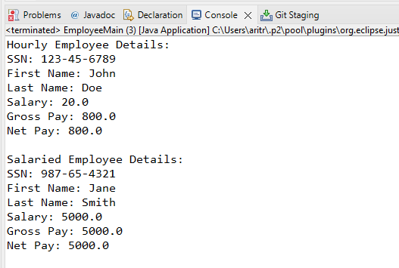

### Write java program to implement Inheritance with following example:

Person will have name and age as data members. Teacher and employee will inherit data members in the super class and create its own method myProfession() to display their profession. Then create objects of Teacher, Permanent, and Contract employee to display their profession..

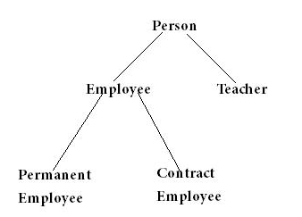

public class Person {

    // Attributes of the Person class

    String name;

    int age;

    // Constructor to initialize the Person object

    public Person(String name, int age) {

        this.name = name; // Set the name of the person

        this.age = age;   // Set the age of the person

    }

    // Method to display the details of the Person

    public void display() {

        System.out.println("Name Of Person: " + name); // Print the person's name

        System.out.println("Age Of Person: " + age);   // Print the person's age

    }

}

//Extending the Person class.

public class Employeee extends Person {

    //Constructor for Employeee objects.

    public Employeee(String name, int age) {

        super(name, age);

    }

    //Prints the profession of the employee.

    public void myProfession() {

        System.out.println(name + " is an Employee.");

    }

}

//Extending the Person class.

public class Teacher extends Person {

    // Constructor for Teacher objects.

    public Teacher(String name, int age) {

        super(name, age);

    }

    //Prints the profession of the teacher.

    public void myProfession() {

        System.out.println(name + " is a Teacher.");

    }

}

//Extending the Employeee class.

public class PermanentEmployee extends Employeee {

    //Constructor for PermanentEmployee objects.

    public PermanentEmployee(String name, int age) {

        super(name, age);

    }

    //Prints the profession of the permanent employee.

    public void myProfession() {

        System.out.println(name + " is a Permanent Employee.");

    }

}

//Extending the Employeee class.

public class ContractEmployee extends Employeee {

    //Constructor for ContractEmployee objects.

    public ContractEmployee(String name, int age) {

        super(name, age);

    }

    //Prints the profession of the contract employee.

    public void myProfession() {

        System.out.println(name + " is a Contract Employee.");

    }

}

**public** **class** PersonMain {

**public** **static** **void** main(String[] args) {

// Creating Objects

Teacher teacher = **new** Teacher("Arvind", 35);

Employeee emp = **new** Employeee("Arun", 37);

PermanentEmployee permanentEmployee = **new** PermanentEmployee("Shubham", 45);

ContractEmployee contractEmployee = **new** ContractEmployee("Ritik", 34);

// Calling the methods

teacher.myProfession();

emp.myProfession();

permanentEmployee.myProfession();

contractEmployee.myProfession();

}

}

**Output**

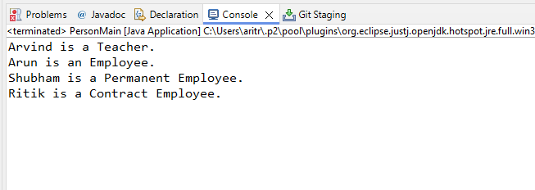

1. **Inheritance Using has a Relationship**

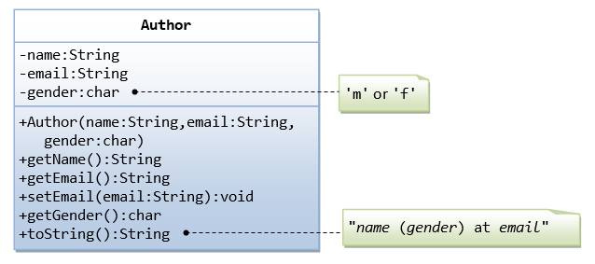

A class called Author is designed as shown in the class diagram. It contains:

* Three private member variables: name (String), email (String), and gender (char of either 'm' or 'f' - you might also use a boolean variable called isMale having value of true or false).
* A constructor to initialize the name, email and gender with the given values.  
  (There is no *default constructor*, as there is no default value for name, email and gender.)
* Public getters/setters: getName(), getEmail(), setEmail(), and getGender().  
  (There are no setters for name and gender, as these properties are not designed to be changed.)

**A Book is written by one Author - Using an "Object" Member Variable**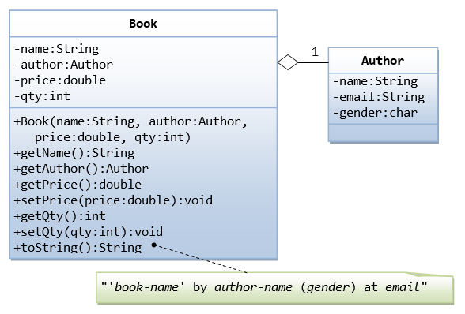

Let's design a Book class. Assume that a book is written by one (and exactly one) author. The Book class (as shown in the class diagram) contains the following members:

* Four private member variables: name (String), author (an *instance* of the Author class we have just created, assuming that each book has exactly one author), price (double), and qty (int).
* The public getters and setters: getName(), getAuthor(), getPrice(), setPrice(), getQty(), setQty().

// Author class representing an author of a book

public class Author {

    // Private member variables to store author's information

    private String name;

    private String email;

    private char gender;

    // Constructor to initialize the name, email, and gender of the author

    public Author(String name, String email, char gender) {

        this.name = name;

        this.email = email;

        this.gender = gender;

    }

    // Getter method to retrieve the name of the author

    public String getName() {

        return name;

    }

    // Getter method to retrieve the email of the author

    public String getEmail() {

        return email;

    }

    // Getter method to retrieve the gender of the author

    public char getGender() {

        return gender;

    }

}

// Book class representing a book written by an author

public class Book {

    // Private member variables to store book information

    private String name;

    private Author author;

    private double price;

    private int qty;

    // Constructor to initialize the name, author, price, and quantity of the book

    public Book(String name, Author author, double price, int qty) {

        this.name = name;

        this.author = author;

        this.price = price;

        this.qty = qty;

    }

    // Getter method to retrieve the name of the book

    public String getName() {

        return name;

    }

    // Getter method to retrieve the author of the book

    public Author getAuthor() {

        return author;

    }

    // Getter method to retrieve the price of the book

    public double getPrice() {

        return price;

    }

    // Setter method to set the price of the book

    public void setPrice(double price) {

        this.price = price;

    }

    // Getter method to retrieve the quantity of the book

    public int getQty() {

        return qty;

    }

    // Setter method to set the quantity of the book

    public void setQty(int qty) {

        this.qty = qty;

    }

}

public class AuthorMain {

    public static void main(String[] args) {

        // Create an author

        Author author = new Author("John Doe", "john@example.com", 'm');

        // Create a book

        Book book = new Book("Java Programming", author, 560, 100);

        // Display book information

        System.out.println("Book Name: " + book.getName());

        System.out.println("Author Name: " + book.getAuthor().getName());

        System.out.println("Author Email: " + book.getAuthor().getEmail());

        System.out.println("Author Gender: " + book.getAuthor().getGender());

        System.out.println("Price: Rs" + book.getPrice());

        System.out.println("Quantity Available: " + book.getQty());

        // Update book price and quantity

        book.setPrice(630);

        book.setQty(50);

        // Display updated book information

        System.out.println("\nUpdated Price: Rs" + book.getPrice());

        System.out.println("Updated Quantity Available: " + book.getQty());

    }

}

**Output**

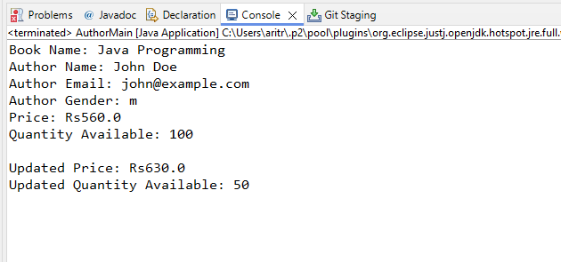

1. Write java program to implement Polymorphism with following example

a)

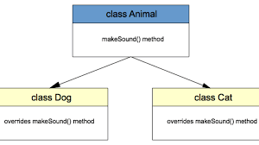

// Animal class representing a generic animal

public class Animal {

    // Method to make a generic animal sound

    public void makeSound() {

        System.out.println("Generic animal sound!");

    }

}

// Dog class representing a specific type of animal - a dog

public class Dog extends Animal {

    // Override the makeSound() method from the Animal class

    @Override

    public void makeSound() {

        System.out.println("Woof!");

    }

}

public class AnimalMain {

    public static void main(String[] args) {

        // Create an instance of Animal

        Animal animals = new Animal();

        // Create instances of Dog and Cat

        Dog d = new Dog();

        Cat c = new Cat();

        // Make sounds of the animals

        System.out.println("Sound of generic animal:");

        animals.makeSound(); // Invoke makeSound() of Animal class

        System.out.println("\nSound of a dog:");

        d.makeSound(); // Invoke overridden makeSound() of Dog class

        System.out.println("\nSound of a cat:");

        c.makeSound(); // Invoke overridden makeSound() of Cat class

    }

}

**Output**

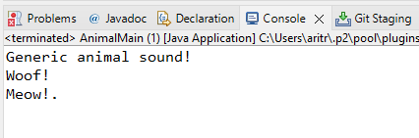

b)

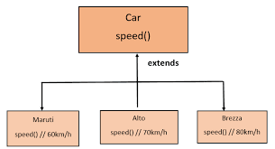

// Car class representing a generic car

public class Car {

    // Method to represent a generic speed of a car

    public void speed() {

        System.out.println("Car Generic Speed.");

    }

}

// Maruti class representing a specific type of car - a Maruti

public class Maruti extends Car {

    // Override the speed() method from the Car class

    @Override

    public void speed() {

        System.out.println("Maruti's Speed is 60 km/h.");

    }

}

// Alto class representing a specific type of car - an Alto

public class Alto extends Car {

    // Override the speed() method from the Car class

    @Override

    public void speed() {

        System.out.println("Alto's Speed is 70 km/h.");

    }

}

// Brezza class representing a specific type of car - a Brezza

public class Brezza extends Car {

    // Override the speed() method from the Car class

    @Override

    public void speed() {

        System.out.println("Brezza's Speed is 80 km/h.");

    }

}

// Main class to test polymorphism with Car, Maruti, Alto, and Brezza classes

public class CarMain {

    public static void main(String[] args) {

        // Create an instance of Car

        Car c = new Car();

        // Create instances of Maruti, Alto, and Brezza

        Maruti m = new Maruti();

        Alto a = new Alto();

        Brezza b = new Brezza();

        // Invoke the speed() method of each object

        System.out.println("Generic Car Speed:");

        c.speed(); // Invoke speed() of Car class

        System.out.println("\nMaruti's Speed:");

        m.speed(); // Invoke overridden speed() of Maruti class

        System.out.println("\nAlto's Speed:");

        a.speed(); // Invoke overridden speed() of Alto class

        System.out.println("\nBrezza's Speed:");

        b.speed(); // Invoke overridden speed() of Brezza class

    }

}

**Output**

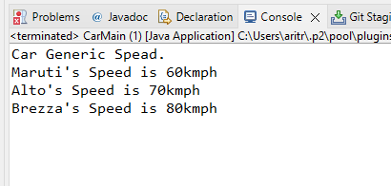

c)

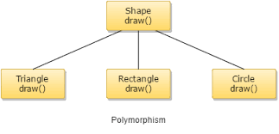

// Shape class representing a generic shape

public class Shape {

    // Method to represent drawing a generic shape

    public void draw() {

        System.out.println("This is a generic shape.");

    }

}

// Triangle class representing a specific type of shape - a triangle

public class Triangle extends Shape {

    // Override the draw() method from the Shape class

    @Override

    public void draw() {

        System.out.println("This is a triangle.");

    }

}

// Rectangle class representing a specific type of shape - a rectangle

public class Rectangle extends Shape {

    // Override the draw() method from the Shape class

    @Override

    public void draw() {

        System.out.println("This is a rectangle.");

    }

}

// Circle class representing a specific type of shape - a circle

public class Circle extends Shape {

    // Override the draw() method from the Shape class

    @Override

    public void draw() {

        System.out.println("This is a circle.");

    }

}

// Main class to test polymorphism with Shape, Triangle, Rectangle, and Circle classes

public class ShapeMain extends Shape {

    public static void main(String[] args) {

        // Create instances of Shape, Triangle, Rectangle, and Circle

        Shape s = new Shape();

        Triangle t = new Triangle();

        Rectangle r = new Rectangle();

        Circle c = new Circle();

        // Invoke the draw() method of each object

        System.out.println("Drawing a generic shape:");

        s.draw(); // Invoke draw() of Shape class

        System.out.println("\nDrawing a triangle:");

        t.draw(); // Invoke overridden draw() of Triangle class

        System.out.println("\nDrawing a rectangle:");

        r.draw(); // Invoke overridden draw() of Rectangle class

        System.out.println("\nDrawing a circle:");

        c.draw(); // Invoke overridden draw() of Circle class

    }

}

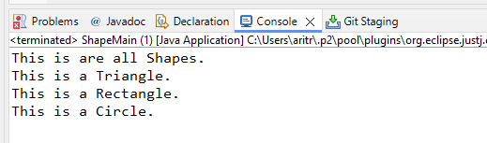

d)

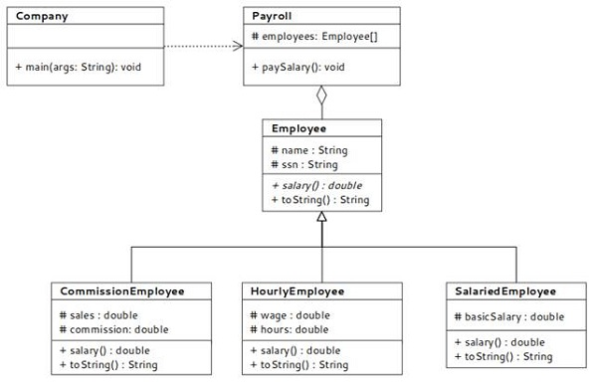

public class Employee1 {

    // Protected attributes for name and SSN, accessible within the class and

    // subclasses

    protected String name;

    protected String ssn;

    // Constructor to initialize the Employee1 object

    public Employee1(String name, String ssn) {

        this.name = name; // Set the name of the employee

        this.ssn = ssn; // Set the SSN of the employee

    }

    // Method to return the salary of the employee

    public double salary() {

        return 20000.00; // Default salary

    }

    // Override the toString method to provide a string representation of the

    // Employee1 object

    @Override

    public String toString() {

        return "Name: " + name + ", SSN: " + ssn + ", Salary: " + salary();

    }

}

public class CommissionEmployee extends Employee1 {

    // Private attributes for sales and commission rate

    private double sales;

    private double commission;

    // Constructor to initialize the CommissionEmployee object

    public CommissionEmployee(String name, String ssn, double sales, double commission) {

        super(name, ssn); // Call the constructor of the superclass Employee1

        this.sales = sales; // Set the sales amount

        this.commission = commission; // Set the commission rate

    }

    // Override the salary method to calculate the salary based on sales and

    // commission

    @Override

    public double salary() {

        return sales * commission; // Calculate salary as sales multiplied by commission rate

    }

    // Override the toString method to provide a string representation of the

    // CommissionEmployee object

    @Override

    public String toString() {

        return super.toString() + ", Sales: " + sales + ", Commission: " + commission;

    }

}

public class HourlyEmployee1 extends Employee1 {

    // Private attributes for wage and hours worked

    private double wage;

    private double hours;

    // Constructor to initialize the HourlyEmployee1 object

    public HourlyEmployee1(String name, String ssn, double wage, double hours) {

        super(name, ssn); // Call the constructor of the superclass Employee1

        this.wage = wage; // Set the hourly wage

        this.hours = hours; // Set the number of hours worked

    }

    // Override the salary method to calculate the salary based on wage and hours worked

    @Override

    public double salary() {

        return wage * hours; // Calculate salary as wage multiplied by hours worked

    }

    // Override the toString method to provide a string representation of the HourlyEmployee1 object

    @Override

    public String toString() {

        return super.toString() + ", Wage: " + wage + ", Hours: " + hours;

    }

}

public class SalariedEmployee1 extends Employee1 {

    // Private attribute for basic salary

    private double basicSalary;

    // Constructor to initialize the SalariedEmployee1 object

    public SalariedEmployee1(String name, String ssn, double basicSalary) {

        super(name, ssn); // Call the constructor of the superclass Employee1

        this.basicSalary = basicSalary; // Set the basic salary

    }

    // Override the salary method to return the basic salary

    @Override

    public double salary() {

        return basicSalary; // Return the basic salary

    }

    // Override the toString method to provide a string representation of the SalariedEmployee1 object

    @Override

    public String toString() {

        return super.toString() + ", Basic Salary: " + basicSalary;

    }

}

import java.util.ArrayList;

public class Payroll {

    // Private attribute to store a list of employees

    private ArrayList<Employee1> employees;

    // Constructor to initialize the Payroll object

    public Payroll() {

        this.employees = new ArrayList<>(); // Initialize the ArrayList of employees

    }

    // Method to add an employee to the payroll

    public void addEmployee(Employee1 employee) {

        employees.add(employee); // Add the provided employee to the list

    }

    // Method to pay salary to all employees and print their details

    public void paySalary() {

        for (Employee1 employee : employees) { // Iterate through each employee in the list

            System.out.println(employee); // Print the details of the employee, including the computed salary

        }

    }

}

public class Company {

    public static void main(String[] args) {

        // Create a Payroll object to manage employee salaries

        Payroll payroll = new Payroll();

        // Add different types of employees to the payroll

        payroll.addEmployee(new CommissionEmployee("Akash Rauth", "785496", 5000, 0.10));

        payroll.addEmployee(new HourlyEmployee1("Juli Sinha", "263548", 20, 40));

        payroll.addEmployee(new SalariedEmployee1("Ritu Raj", "32548", 60000));

        // Pay salary to all employees and print their details

        payroll.paySalary();

    }

}

**Output**

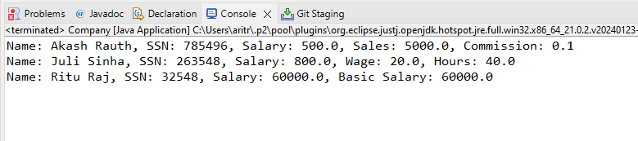

1. Write java program to implement interface with following example

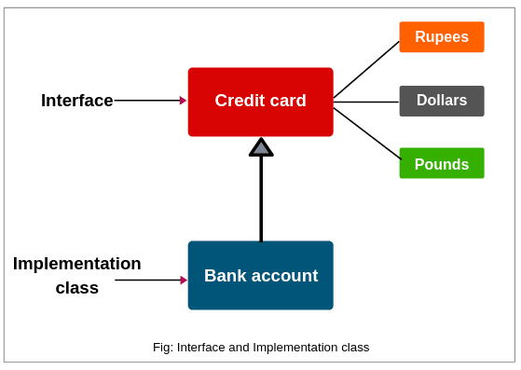

// Interface representing a credit card with methods for making payments in different currencies

public interface CreditCard {

    // Method to make payment in Rupees

    void rupees(float amount);

    // Method to make payment in Dollars

    void dollar(float amount);

    // Method to make payment in Pounds

    void pound(float amount);

}

// Class implementing the CreditCard interface

class Bank implements CreditCard {

    // Method implementation for making payment in Rupees

    @Override

    public void rupees(float amount) {

        System.out.println(amount + " paid in Rupees");

    }

    // Method implementation for making payment in Dollars

    @Override

    public void dollar(float amount) {

        System.out.println(amount + " paid in Dollar");

    }

    // Method implementation for making payment in Pounds

    @Override

    public void pound(float amount) {

        System.out.println(amount + " paid in Pound");

    }

}

import java.util.Scanner;

// Main class to facilitate transactions using Bank class

public class BankAccountMain {

    public static void main(String[] args) {

        Scanner sc = new Scanner(System.in);

        // Prompt user to enter the amount to transact

        System.out.println("Enter the amount you want to transact: ");

        float amount = sc.nextFloat();

        // Display options for currency selection

        System.out.println("Choose an option from below: ");

        System.out.println("Press 1: From Rupees. ");

        System.out.println("Press 2: From Dollar. ");

        System.out.println("Press 3: From Pound. ");

        System.out.println("Press 4: Exit");

        // Create a reference variable of type CreditCard

        CreditCard c;

        // Read user's choice

        int choice = sc.nextInt();

        switch (choice) {

            case 1:

                c = new Bank();

                c.rupees(amount); // Make payment in Rupees

                break;

            case 2:

                c = new Bank();

                c.dollar(amount); // Make payment in Dollars

                break;

            case 3:

                c = new Bank();

                c.pound(amount); // Make payment in Pounds

                break;

            case 4:

                System.out.println("Thanks for using.");

                break;

            default:

                System.out.println("Invalid Option! Try Again");

        }

        sc.close(); // Close the scanner

    }

}

**Output**

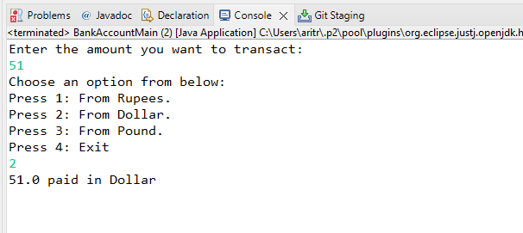

**Packages (Assignment 3)**

**Exception**

1. Write a program to demonstrate the use of try, catch, finally throw and throws keywords and demonstrate the following points in the program.

a) Multiple catch blocks.

b) try-catch-finally combination.

c) try-finally combination.

d) Nested try blocks

public class ExceptionHandlingDemo {

    public static void main(String[] args) {

        // (a) Multiple catch blocks

        try {

            int result = divide(10, 0);

            System.out.println("Result: " + result);

        } catch (ArithmeticException e) {

            System.out.println("Error: " + e.getMessage());

        } catch (Exception e) {

            System.out.println("General Exception: " + e.getMessage());

        }

        // (b) try-catch-finally combination

        try {

            int[] arr = new int[5];

            System.out.println("Accessing out of bounds element: " + arr[10]);

        } catch (ArrayIndexOutOfBoundsException e) {

            System.out.println("Error: " + e.getMessage());

        } finally {

            System.out.println("Finally block executed.");

        }

        // (c) try-finally combination

        int result;

        try {

            result = divide(15, 3);

        } finally {

            System.out.println("Finally block executed in try-finally combination.");

        }

        // (d) Nested try blocks

        try {

            System.out.println("Outer try block");

            try {

                System.out.println("Nested try block");

                throw new RuntimeException("Nested exception");

            } catch (RuntimeException e) {

                System.out.println("Caught nested exception: " + e.getMessage());

                throw e; // Re-throwing the exception

            }

        } catch (Exception e) {

            System.out.println("Caught re-thrown exception: " + e.getMessage());

        }

        // Demonstrating throws keyword

        try {

            performOperation();

        } catch (CustomException e) {

            System.out.println("Error: " + e.getMessage());

        }

    }

    private static int divide(int a, int b) {

        if (b == 0) {

            throw new ArithmeticException("Division by zero");

        }

        return a / b;

    }

    private static void performOperation() throws CustomException {

        throw new CustomException("Custom exception occurred");

    }

}

class CustomException extends Exception {

    public CustomException(String message) {

        super(message);

    }

}

**Output**

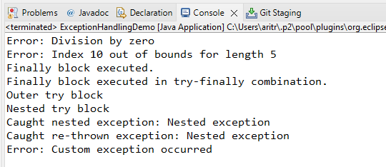

1. Write a java application for checking the bank account funds using InsufficientFundsException using user defined exception using throw keword and create a class for CheckingAccount with methods withdraw() and getBalance() Among these withdraw() should throw an InsufficientFundsException.

// Custom exception class for handling insufficient funds

class InsufficientFundsException extends Exception {

    public InsufficientFundsException(String message) {

        super(message);

    }

}

// CheckingAccount class representing a bank account

class CheckingAccount {

    private double balance; // The current balance of the account

    // Constructor to initialize the account with an initial balance

    public CheckingAccount(double initialBalance) {

        this.balance = initialBalance;

    }

    // Method to deposit funds into the account

    public void deposit(double amount) {

        balance += amount;

    }

    // Method to get the current balance of the account

    public double getBalance() {

        return balance;

    }

    // Method to withdraw funds from the account

    public void withdraw(double amount) throws InsufficientFundsException {

        // Check if the withdrawal amount exceeds the balance

        if (amount > balance) {

            // Throw an InsufficientFundsException if there are not enough funds

            throw new InsufficientFundsException("Insufficient funds. Current balance: " + balance);

        }

        // Deduct the amount from the balance if sufficient funds are available

        balance -= amount;

        System.out.println("Withdrawal successful. New balance: " + balance);

    }

}

public class BankAccountFundsChecker {

    public static void main(String[] args) {

        CheckingAccount account = new CheckingAccount(1000.0); // Create a checking account with an initial balance of $1000

        try {

            // Attempt to withdraw $500

            account.withdraw(500.0);

            // Attempt to withdraw $700 (insufficient funds)

            account.withdraw(700.0);

        } catch (InsufficientFundsException e) {

            // Catch and handle the InsufficientFundsException

            System.out.println("Error: " + e.getMessage());

        }

        // Print the current balance after withdrawal attempts

        System.out.println("Current balance: " + account.getBalance());

    }

}

**Output**

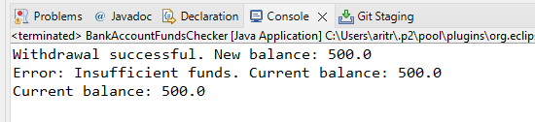

**Collection**

1. Write a java program to do following operations on Array List(Integer)
2. Add element
3. Remove a particular element
4. Modify
5. View All elements (Use Iterator)
6. View a Particular element ( get() )
7. Sort (Collections.sort)

import java.util.ArrayList;

import java.util.Collections;

import java.util.Iterator;

public class ArrayListExample {

    public static void main(String[] args) {

        // Create an ArrayList of Integer type

        ArrayList<Integer> al = new ArrayList<>();

        // Add elements to the ArrayList

        al.add(24);

        al.add(14);

        al.add(52);

        al.add(11);

        al.add(34);

        // Display the ArrayList using an iterator

        System.out.println("Displaying Array");

        Iterator<Integer> it = al.iterator();

        while (it.hasNext()) {

            System.out.println(it.next());

        }

        // Remove an element from the ArrayList

        System.out.println("After Deleting");

        int pos = al.indexOf(52); // Find the position of the element to be removed

        al.remove(pos); // Remove the element at the found position

        System.out.println(al);

        // Update the first element of the ArrayList

        System.out.println("After Update");

        al.set(0, 55);

        System.out.println(al);

        // Retrieve an element from the ArrayList

        int a = al.get(3); // Get the element at index 3

        System.out.println(a);

        // Sort the ArrayList

        System.out.println("After Sorting: ");

        Collections.sort(al); // Sort the ArrayList in ascending order

        System.out.println(al);

    }

}

**Output**

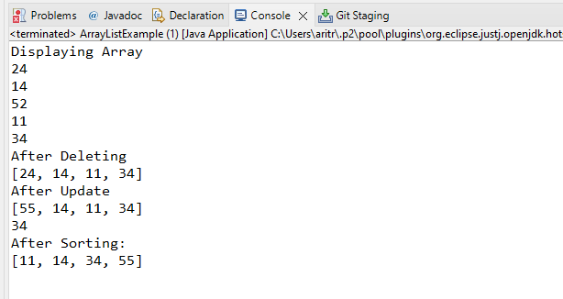

1. Write a Java menu driven program to perform the following operations-using Array List Create a class called Player with the following instance variable

Player name

total run

no of wicket

no of matches

country

no-of-century

Category = null

* Create 5 Players add into the Array List

* Display the player details who has scored maximum no of runs

* Sort the players by name

* Remove the player who has scored less than 100 runs

* Update Category ‘A’ if player has got 10 century else update Grade ‘B’

**public** **class** Player {

**private** String playerName; // Name of the player

**private** **int** totalRuns; // Total runs scored by the player

**private** **int** noOfWickets; // Number of wickets taken by the player

**private** **int** noOfMatches; // Number of matches played by the player

**private** String country; // Country the player represents

**private** **int** noOfCenturies; // Number of centuries scored by the player

**private** String category; // Category of the player (A or B)

// Constructor to initialize a Player object

**public** Player(String playerName, **int** totalRuns, **int** noOfWickets, **int** noOfMatches, String country, **int** noOfCenturies) {

**this**.playerName = playerName;

**this**.totalRuns = totalRuns;

**this**.noOfWickets = noOfWickets;

**this**.noOfMatches = noOfMatches;

**this**.country = country;

**this**.noOfCenturies = noOfCenturies;

**this**.category = **null**; // Category is initially null

}

// Getter method to retrieve the player's name

**public** String getPlayerName() {

**return** playerName;

}

// Getter method to retrieve the total runs scored by the player

**public** **int** getTotalRuns() {

**return** totalRuns;

}

// Method to update the category of the player based on the number of centuries

**public** **void** updateCategory() {

**if** (noOfCenturies >= 10) {

category = "A"; // Category A for players with 10 or more centuries

} **else** {

category = "B"; // Category B for players with less than 10 centuries

}

}

// Override the toString method to provide a string representation of the player

@Override

**public** String toString() {

**return** "Player Name = " + playerName + ", Total Runs = " + totalRuns + ", No. Of Wickets = " + noOfWickets

+ ", No Of Matches = " + noOfMatches + ", Country = " + country + ", No Of Centuries = " + noOfCenturies

+ ", Category = " + category;

}

}

import java.util.ArrayList;

import java.util.Collections;

import java.util.Comparator;

import java.util.Scanner;

public class PlayerManager {

    private static ArrayList<Player> players = new ArrayList<>(); // List to store players

    private static Scanner scanner = new Scanner(System.in); // Scanner for user input

    public static void main(String[] args) {

        createPlayers(); // Create initial list of players

        int choice;

        do {

            displayMenu(); // Display the menu

            choice = scanner.nextInt();

            scanner.nextLine(); // Consume the newline character

            handleChoice(choice); // Handle user choice

        } while (choice != 5); // Exit if choice is 5

    }

    // Method to create initial list of players

    private static void createPlayers() {

        Player player1 = new Player("Virat Kohli", 12000, 10, 200, "India", 15);

        Player player2 = new Player("Rohit Sharma", 10500, 5, 180, "India", 12);

        Player player3 = new Player("Joe Root", 8000, 20, 150, "England", 5);

        Player player4 = new Player("Babar Azam", 6500, 8, 120, "Pakistan", 8);

        Player player5 = new Player("Kane Williamson", 7800, 15, 160, "New Zealand", 9);

        players.add(player1);

        players.add(player2);

        players.add(player3);

        players.add(player4);

        players.add(player5);

    }

    // Method to display the menu

    private static void displayMenu() {

        System.out.println("\nPlayer Manager Menu:");

        System.out.println("1. Display player with maximum runs");

        System.out.println("2. Sort players by name");

        System.out.println("3. Remove players with less than 100 runs");

        System.out.println("4. Update player category");

        System.out.println("5. Exit");

        System.out.print("Enter your choice: ");

    }

    // Method to handle user choices

    private static void handleChoice(int choice) {

        switch (choice) {

            case 1:

                displayPlayerWithMaximumRuns(); // Display player with max runs

                break;

            case 2:

                sortPlayersByName(); // Sort players by name

                break;

            case 3:

                removePlayersWithLessThan100Runs(); // Remove players with < 100 runs

                break;

            case 4:

                updatePlayerCategory(); // Update player categories

                break;

            case 5:

                System.out.println("Exiting program...");

                break;

            default:

                System.out.println("Invalid choice. Please try again.");

        }

    }

    // Method to display the player with maximum runs

    private static void displayPlayerWithMaximumRuns() {

        Player playerWithMaxRuns = players.stream()

                .max(Comparator.comparingInt(Player::getTotalRuns))

                .orElse(null);

        if (playerWithMaxRuns != null) {

            System.out.println("Player with maximum runs: " + playerWithMaxRuns);

        } else {

            System.out.println("No players found.");

        }

    }

    // Method to sort players by name

    private static void sortPlayersByName() {

        players.sort(Comparator.comparing(Player::getPlayerName));

        System.out.println("Players sorted by name:");

        for (Player player : players) {

            System.out.println(player);

        }

    }

    // Method to remove players with less than 100 runs

    private static void removePlayersWithLessThan100Runs() {

        players.removeIf(player -> player.getTotalRuns() < 100);

        System.out.println("Players with less than 100 runs removed.");

    }

    // Method to update player categories

    private static void updatePlayerCategory() {

        for (Player player : players) {

            player.updateCategory();

        }

        System.out.println("Player categories updated.");

    }

}

**Output**

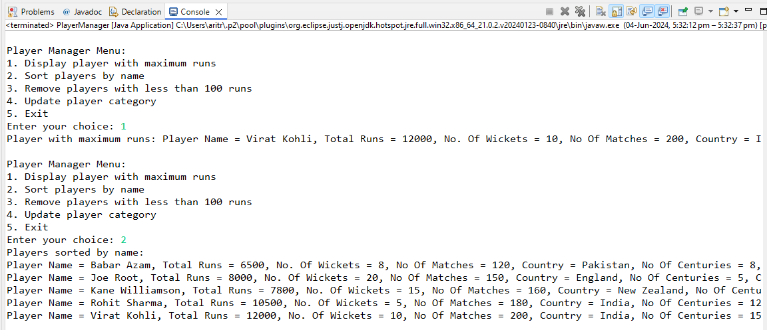

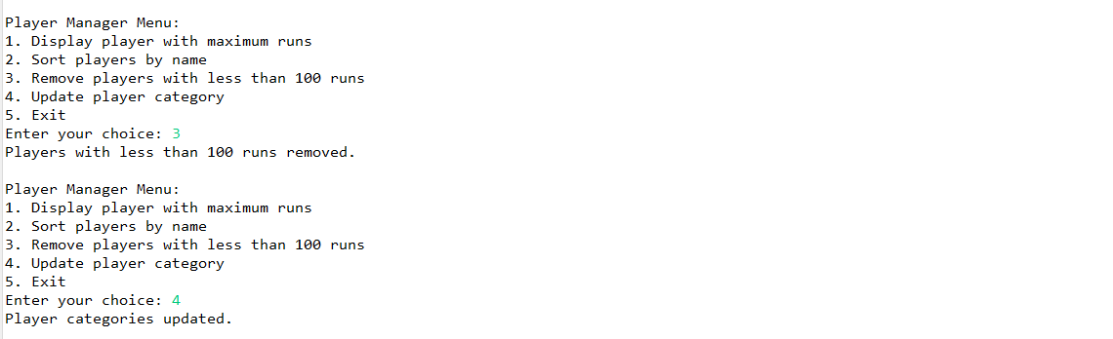

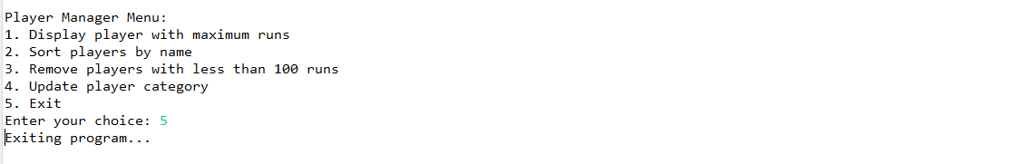

1. Write a java program to do push, pop, display objects on stacks(integer).

import java.util.Stack;

public class StackEx {

    public static void main(String[] args) {

        // Create a new Stack instance of Integer type

        Stack<Integer> s = new Stack<>();

        // Add elements to the stack

        s.add(10);

        s.add(20);

        s.add(30);

        s.add(40);

        s.add(50);

        // Print the stack contents

        System.out.println("Stack contents after initial additions: " + s);

        // Push an element onto the stack and retrieve the element

        Integer ele = s.push(60);

        System.out.println("Element pushed onto stack: " + ele);

        System.out.println("Stack contents after pushing 60: " + s);

        // Pop an element from the stack and retrieve the element

        Integer ele1 = s.pop();

        System.out.println("Element popped from stack: " + ele1);

        System.out.println("Stack contents after popping: " + s);

        // Iterate through the stack using enhanced for loop

        System.out.println("Stack contents using enhanced for loop:");

        for (Integer n : s) {

            System.out.println(n);

        }

    }

}

**Output**

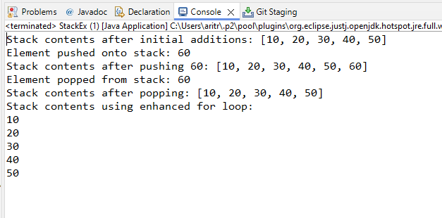

1. Implement single linked list(Integer) with following options:

a. Insert at the beginning.

b. Insert at given position.

c. Insert after a given node.

d. Delete at the beginning.

e. Delete at given position.

f. Delete after a given node.

g. Reverse the linked list.

import java.util.LinkedList;

public class LinkedListEx {

    public static void main(String[] args) {

        // Create a LinkedList of Integer type

        LinkedList<Integer> ll = new LinkedList<>();

        // Add elements to the linked list

        ll.add(101);

        ll.add(102);

        ll.add(103);

        ll.add(104);

        ll.add(105);

        ll.add(106);

        // Display the initial linked list

        System.out.println("Initial List: " + ll);

        // Insert an element at the beginning of the linked list

        ll.addFirst(100);

        System.out.println("After adding at the beginning: " + ll);

        // Insert an element at a specific position in the linked list

        ll.add(5, 205);

        System.out.println("After inserting at position 5: " + ll);

        // Insert an element after a given node in the linked list

        ll.add(6, 206);

        System.out.println("After inserting after position 5: " + ll);

        // Remove the first element from the linked list

        ll.removeFirst();

        System.out.println("After deleting from the beginning: " + ll);

        // Remove an element at a specific position from the linked list

        ll.remove(3);

        System.out.println("After deleting from position 3: " + ll);

    }

}

**Output**

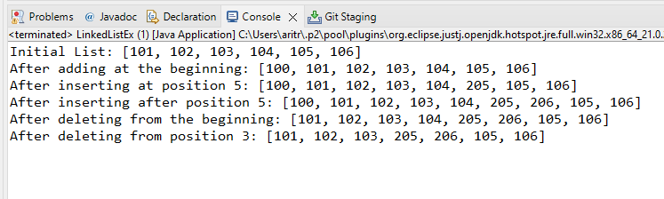

1. Write a Java program menu driven to perform the following operations using Map

* Create a class called Book with the following instance variable

name

price

author name

isbn no;

publication

* Create 5 Objects of book class

* Add all the object in to the Map using key as integer(book id) and value as Book Object

* Display all the map object using for each

* Read any key from the user and display the particular book object based on key

* Reduce the price by 10% for a particular publication books and display all object with reduced price.

public class Book {

    String name; // Name of the book

    double price; // Price of the book

    String authorName; // Name of the author

    String isbnNo; // ISBN number of the book

    String publication; // Publication information

    // Constructor to initialize a Book object

    public Book(String name, double price, String authorName, String isbnNo, String publication) {

        this.name = name;

        this.price = price;

        this.authorName = authorName;

        this.isbnNo = isbnNo;

        this.publication = publication;

    }

    // Overriding the toString method to provide a string representation of a Book object

    @Override

    public String toString() {

        return "[Book Name=" + name + ", price=" + price + ", Author Name=" + authorName + ", ISBN No=" + isbnNo

                + ", Publication=" + publication + "]";

    }

}

**import** java.util.HashMap;

**import** java.util.Map;

**import** java.util.Scanner;

**public** **class** MapBookOperations {

**public** **static** **void** main(String[] args) {

Map<Integer, Book> bookMap = **new** HashMap<>(); // Map to store books with integer keys

Scanner scanner = **new** Scanner(System.***in***);

// Create 5 objects of the Book class

Book book1 = **new** Book("Java Programming", 499.99, "James Goslin", "978-0123456789", "ABC Publications");

Book book2 = **new** Book("Python Basics", 349.99, "Fletcher", "978-9876543210", "XYZ Books");

Book book3 = **new** Book("Web Development", 599.99, "Jon Duckett", "978-1234567890", "ABC Publications");

Book book4 = **new** Book("Database Management", 699.99, "Abraham Silberschatz", "978-0987654321", "PQR Publishing");

Book book5 = **new** Book("Data Structures", 399.99, "Thomas H. Cormen", "978-5678901234", "XYZ Books");

// Add all the objects to the Map with integer keys

bookMap.put(1, book1);

bookMap.put(2, book2);

bookMap.put(3, book3);

bookMap.put(4, book4);

bookMap.put(5, book5);

**int** choice;

**do** {

*displayMenu*();

choice = scanner.nextInt();

**switch** (choice) {

**case** 1:

*displayAllBooks*(bookMap);

**break**;

**case** 2:

*displayBookByKey*(bookMap, scanner);

**break**;

**case** 3:

*reducePrice*(bookMap, scanner);

**break**;

**case** 4:

System.***out***.println("Exiting...");

**break**;

**default**:

System.***out***.println("Invalid choice. Please try again.");

}

} **while** (choice != 4);

scanner.close();

}

// Display the menu options

**public** **static** **void** displayMenu() {

System.***out***.println("\nMenu:");

System.***out***.println("1. Display all books");

System.***out***.println("2. Display book by key");

System.***out***.println("3. Reduce price for a particular publication");

System.***out***.println("4. Exit");

System.***out***.print("Enter your choice: ");

}

// Display all books in the map

**public** **static** **void** displayAllBooks(Map<Integer, Book> bookMap) {

System.***out***.println("\nAll books:");

**for** (Map.Entry<Integer, Book> entry : bookMap.entrySet()) {

System.***out***.println(entry.getKey() + " "+ entry.getValue());

}

}

// Display a book based on user input key

**public** **static** **void** displayBookByKey(Map<Integer, Book> bookMap, Scanner scanner) {

System.***out***.print("\nEnter the key: ");

**int** key = scanner.nextInt();

**if** (bookMap.containsKey(key)) {

System.***out***.println(bookMap.get(key));

} **else** {

System.***out***.println("Book with key " + key + " not found.");

}

}

// Reduce the price for books from a particular publication

**public** **static** **void** reducePrice(Map<Integer, Book> bookMap, Scanner scanner) {

System.***out***.print("\nEnter the publication: ");

scanner.nextLine(); // Consume newline character

String publication = scanner.nextLine();

**double** discount = 0.9; // 10% discount

System.***out***.println("\nBooks with reduced price:");

**for** (Map.Entry<Integer, Book> entry : bookMap.entrySet()) {

Book book = entry.getValue();

**if** (book.publication.equalsIgnoreCase(publication)) {

book.price *= discount; // Apply the discount

System.***out***.println("Key: " + entry.getKey() + ", Value: " + book);

}

}

}

}

**Output**

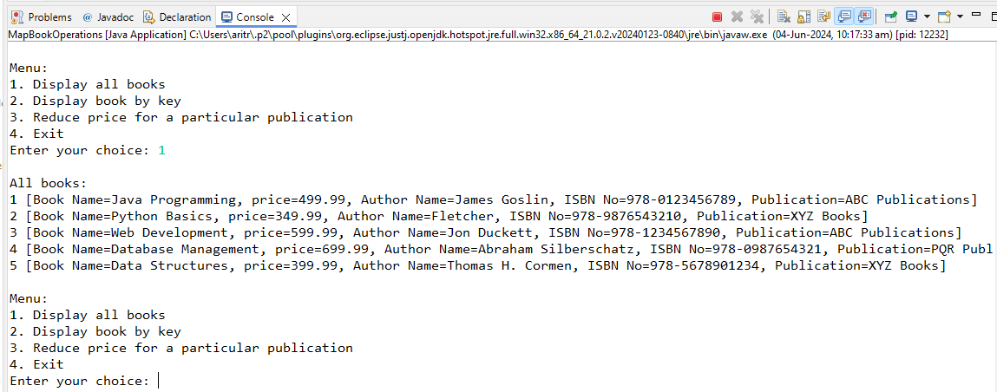

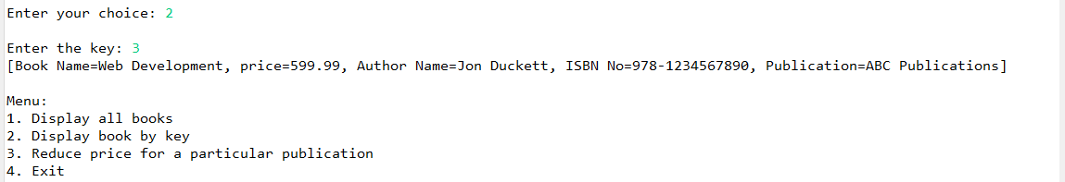

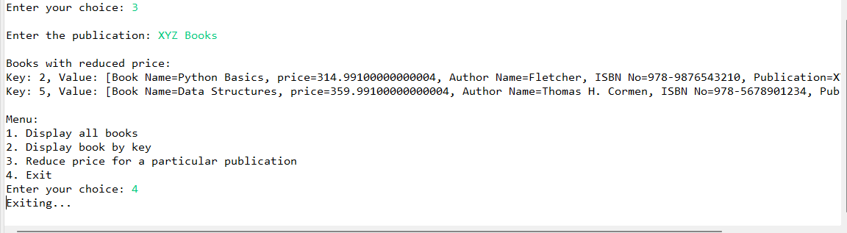

1. Write a Java program to simulate an online shopping cart.

A shopping cart is a collection of items selected by a customer for purchase. A user can add items to the cart, remove them, empty the cart, view the items in the cart, view the items in the shop, and end shopping and proceed to checkout. (using arraylist)

public class Item {

    String name; // Name of the item

    double price; // Price of the item

   // Constructor to initialize an Item object with a name and price

   public Item(String name, double price) {

       this.name = name;

       this.price = price;

   }

   // Getter method to retrieve the name of the item

   public String getName() {

       return name;

   }

   // Getter method to retrieve the price of the item

   public double getPrice() {

       return price;

   }

   // Override the toString method to provide a string representation of the item

   @Override

   public String toString() {

       return "Item: " + name + ", Price: ₹" + price;

   }

}

import java.util.ArrayList;

import java.util.Scanner;

public class ShoppingCart {

    ArrayList<Item> cart; // List to store items in the cart

    ArrayList<Item> shop; // List to store items in the shop

    Scanner scanner; // Scanner object for user input

    // Constructor to initialize the shopping cart and shop

    public ShoppingCart() {

        cart = new ArrayList<>();

        shop = new ArrayList<>();

        scanner = new Scanner(System.in);

        initializeShop();

    }

    // Method to initialize the shop with some items

    public void initializeShop() {

        shop.add(new Item("T-shirt", 250.99));

        shop.add(new Item("Jeans", 649.99));

        shop.add(new Item("Sneakers", 748.99));

        shop.add(new Item("Backpack", 948.99));

        shop.add(new Item("Sunglasses", 600.99));

    }

    // Method to start the shopping cart system

    public void start() {

        int choice;

        do {

            displayMenu();

            choice = scanner.nextInt();

            scanner.nextLine(); // Consume the newline character

            handleChoice(choice);

        } while (choice != 6);

        scanner.close(); // Close the scanner after use

    }

    // Method to display the shopping cart menu

    public void displayMenu() {

        System.out.println("\nShopping Cart Menu:");

        System.out.println("1. View items in shop");

        System.out.println("2. Add item to cart");

        System.out.println("3. Remove item from cart");

        System.out.println("4. View cart");

        System.out.println("5. Empty cart");

        System.out.println("6. Checkout");

        System.out.print("Enter your choice: ");

    }

    // Method to handle user choices in the shopping cart menu

    public void handleChoice(int choice) {

        switch (choice) {

            case 1:

                viewShop();

                break;

            case 2:

                addToCart();

                break;

            case 3:

                removeFromCart();

                break;

            case 4:

                viewCart();

                break;

            case 5:

                emptyCart();

                break;

            case 6:

                checkout();

                break;

            default:

                System.out.println("Invalid choice. Please try again.");

        }

    }

    // Method to display items in the shop

    public void viewShop() {

        System.out.println("\nItems in the shop:");

        for (int i = 0; i < shop.size(); i++) {

            System.out.println((i + 1) + ". " + shop.get(i));

        }

    }

    // Method to add an item to the cart

    public void addToCart() {

        viewShop();

        System.out.print("Enter the item number to add to cart: ");

        int itemNumber = scanner.nextInt();

        scanner.nextLine(); // Consume the newline character

        if (itemNumber > 0 && itemNumber <= shop.size()) {

            Item item = shop.get(itemNumber - 1);

            cart.add(item);

            System.out.println(item.getName() + " added to cart.");

        } else {

            System.out.println("Invalid item number.");

        }

    }

    // Method to remove an item from the cart

    public void removeFromCart() {

        viewCart();

        System.out.print("Enter the item number to remove from cart: ");

        int itemNumber = scanner.nextInt();

        scanner.nextLine(); // Consume the newline character

        if (itemNumber > 0 && itemNumber <= cart.size()) {

            Item item = cart.remove(itemNumber - 1);

            System.out.println(item.getName() + " removed from cart.");

        } else {

            System.out.println("Invalid item number.");

        }

    }

    // Method to display items in the cart

    public void viewCart() {

        System.out.println("\nItems in your cart:");

        if (cart.isEmpty()) {

            System.out.println("Your cart is empty.");

        } else {

            for (int i = 0; i < cart.size(); i++) {

                System.out.println((i + 1) + ". " + cart.get(i));

            }

        }

    }

    // Method to empty the cart

    public void emptyCart() {

        cart.clear();

        System.out.println("Cart emptied.");

    }

    // Method to proceed to checkout

    public void checkout() {

        if (cart.isEmpty()) {

            System.out.println("Your cart is empty. Nothing to checkout.");

        } else {

            double total = 0;

            System.out.println("\nItems in your cart:");

            for (Item item : cart) {

                System.out.println(item);

                total += item.getPrice();

            }

            System.out.println("Total: ₹" + total);

            System.out.println("Thank you for your purchase!");

            cart.clear(); // Clear the cart after checkout

        }

    }

    // Main method to create an instance of ShoppingCart and start the shopping cart system

    public static void main(String[] args) {

        ShoppingCart shoppingCart = new ShoppingCart();

        shoppingCart.start();

    }

}

**Output**

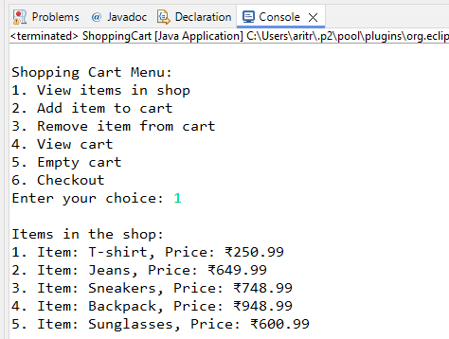 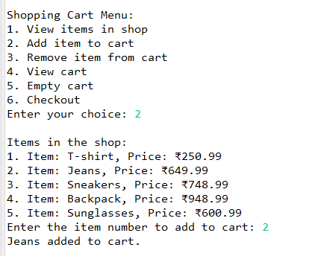

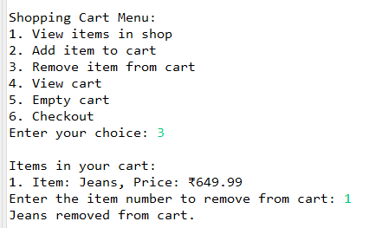 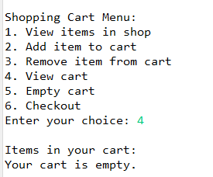

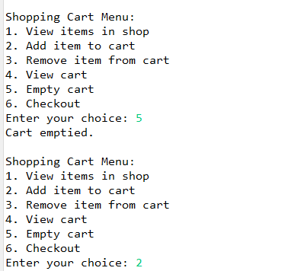  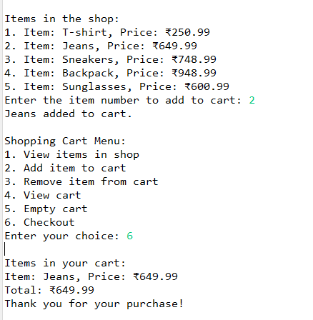

**File Handling**

1. Program to count the number of character, no of word, no of lines in a given file.

import java.io.BufferedReader;

import java.io.FileReader;

import java.io.FileWriter;

import java.io.IOException;

public class Test {

    public static void main(String[] args) throws IOException {

        // Create a FileWriter object to write to the file

        FileWriter fw = new FileWriter("D:\\CDAC2024\\Core Java\\240350120028_AritraDas\\Assignment3\\src\\d.txt");

        String str1 = "Welcome Here";

        fw.write(str1); // Write the string to the file

        fw.close(); // Close the FileWriter to save the file

        try {

            // Create a FileReader and BufferedReader to read the file

            FileReader f = new FileReader("D:\\CDAC2024\\Core Java\\240350120028_AritraDas\\Assignment3\\src\\d.txt");

            BufferedReader b = new BufferedReader(f);

            int nLine = 0; // Initialize line count

            int nword = 0; // Initialize word count

            int nChars = 0; // Initialize character count

            String line;

            // Loop through each line in the file

            while ((line = b.readLine()) != null) {

                nLine++; // Increment line count

                nChars += line.length(); // Increment character count by the length of the line

                String[] words = line.split("\\s+"); // Split the line into words

                nword += words.length; // Increment word count by the number of words in the line

            }

            b.close(); // Close the BufferedReader

            // Print the counts

            System.out.println("Number of lines: " + nLine);

            System.out.println("Number of characters: " + nChars);

            System.out.println("Number of words: " + nword);

        } catch (Exception e) {

            System.out.println("File not found or cannot be read");

            e.printStackTrace(); // Print the stack trace for debugging

        }

        // Search for a specific word in the file

        String wordToSearch = "Welcome";

        try {

            // Create a FileReader and BufferedReader to read the file

            FileReader f = new FileReader("D:\\CDAC2024\\Core Java\\240350120028_AritraDas\\Assignment3\\src\\d.txt");

            BufferedReader b = new BufferedReader(f);

            String line;

            int lineNumber = 0;

            // Loop through each line in the file

            while ((line = b.readLine()) != null) {

                lineNumber++; // Increment line number

                // Check if the line contains the word to search

                if (line.contains(wordToSearch)) {

                    System.out.println("Word \"" + wordToSearch + "\" found at line " + lineNumber);

                    break; // Exit the loop once the word is found

                }

            }

            b.close(); // Close the BufferedReader

        } catch (IOException e) {

            System.err.println("Error reading the file: " + e.getMessage());

        }

    }

}

**Output**

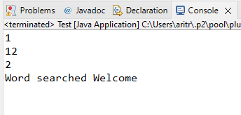

1. Java Program to Search for a given word in a File ?

import java.io.File;

import java.io.FileNotFoundException;

import java.util.Scanner;

public class WordSearch {

    public static void main(String[] args) {

        // The word to search for

        String wordToFind = "Welcome";

        // The file to search in

        File file = new File("D:\\CDAC2024\\Core Java\\240350120028_AritraDas\\Assignment3\\src\\d.txt");

        try {

            // Create a Scanner object to read the file

            Scanner scanner = new Scanner(file);

            boolean found = false; // Flag to track if the word is found

            // Loop through each line in the file

            while (scanner.hasNextLine()) {

                String line = scanner.nextLine(); // Read the next line

                // Check if the line contains the word to search for

                if (line.contains(wordToFind)) {

                    System.out.println("Word found: " + wordToFind);

                    found = true; // Set the flag to true if the word is found

                    break; // Exit the loop once the word is found

                }

            }

            // If the word is not found in the entire file, print a message

            if (!found) {

                System.out.println("Word not found: " + wordToFind);

            }

            // Close the Scanner

            scanner.close();

        } catch (FileNotFoundException e) {

            System.out.println("File not found: " + e.getMessage());

        }

    }

}

**Output**

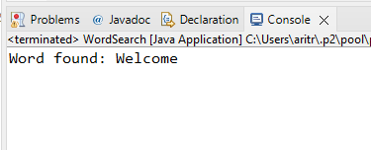

1. Read source and destination file from the user as an argument. Copy the contents of the source into another destination file in a faster, efficient way.

import java.io.FileWriter;

import java.io.IOException;

public class Source {

    public static void main(String[] args) throws IOException {

        // Create a FileWriter object to write to the file

        FileWriter fw = new FileWriter("D:\\CDAC2024\\Core Java\\240350120028_AritraDas\\Assignment3\\src\\src.txt");

        // Strings to be written to the file

        String str1 = "Welcome to Coding World";

        String str2 = "Hello Everyone";

        // Write the strings to the file, each followed by a newline character

        fw.write(str1 + '\n');

        fw.write(str2 + '\n');

        // Close the FileWriter to save the file

        fw.close();

    }

}

import java.io.BufferedReader;

import java.io.FileReader;

import java.io.FileWriter;

import java.io.IOException;

public class Destination {

    public static void main(String[] args) throws IOException {

        // Write initial content to des.txt

        try {

            FileWriter fw = new FileWriter("D:\\CDAC2024\\Core Java\\240350120028_AritraDas\\Assignment3\\src\\des.txt");

            String str1 = "Good Evening";

            String str2 = "Nice to meet you all";

            fw.write(str1 + '\n');

            fw.write(str2 + '\n');

            fw.close();

        } catch (IOException e) {

            e.printStackTrace();

        }

        // Read from src.txt and write to des.txt

        try {

            // Read from src.txt

            FileReader fr = new FileReader("D:\\CDAC2024\\Core Java\\240350120028_AritraDas\\Assignment3\\src\\src.txt");

            BufferedReader br = new BufferedReader(fr);

            String st = br.readLine();

            String st2 = br.readLine();

            // Write to des.txt (overwriting previous content)

            FileWriter fw = new FileWriter("D:\\CDAC2024\\Core Java\\240350120028_AritraDas\\Assignment3\\src\\des.txt");

            fw.write(st + '\n');

            fw.write(st2 + '\n');

            // Print the content read from src.txt

            System.out.println(st);

            System.out.println(st2);

            // Close readers and writers

            br.close();

            fw.close();

        } catch (IOException e) {

            e.printStackTrace();

        }

    }

}

**Output**

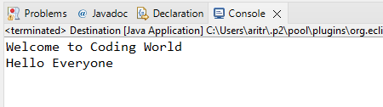

1. Write a program to serialize the student object(id,name,marks,subject) *Write a student object (minimum five) into the file

* Read the same from the file,

* Find out result and display the student details along with result.

* Find out how many no of students passed and failed in a particular

Subject.

*Sort the students object based on marks.

import java.io.Serializable;

// The Student class implements Serializable to allow objects of this class to be serialized

public class Student implements Serializable {

    // Fields for the Student class

    int id;

    String name;

    int marks;

    String subject;

    String result;

    // Constructor to initialize the Student object

    public Student(int id, String name, int marks, String subject) {

        super();

        this.id = id;

        this.name = name;

        this.marks = marks;

        this.subject = subject;

    }

    // Getter and setter methods for id

    public int getId() {

        return id;

    }

    public void setId(int id) {

        this.id = id;

    }

    // Getter and setter methods for name

    public String getName() {

        return name;

    }

    public void setName(String name) {

        this.name = name;

    }

    // Getter and setter methods for marks

    public int getMarks() {

        return marks;

    }

    public void setMarks(int marks) {

        this.marks = marks;

    }

    // Getter and setter methods for subject

    public String getSubject() {

        return subject;

    }

    public void setSubject(String subject) {

        this.subject = subject;

    }

    // Getter and setter methods for result

    public String getResult() {

        return result;

    }

    public void setResult(String result) {

        this.result = result;

    }

    // Override the toString() method to return a string representation of the Student object

    @Override

    public String toString() {

        return "Student [id=" + id + ", name=" + name + ", marks=" + marks + ", subject=" + subject + ", result="

                + result + "]";

    }

}

import java.io.FileInputStream;

import java.io.FileOutputStream;

import java.io.IOException;

import java.io.ObjectInputStream;

import java.io.ObjectOutputStream;

import java.util.ArrayList;

import java.util.Collections;

import java.util.Comparator;

public class StudentManagement {

    public static void main(String[] args) throws IOException, ClassNotFoundException {

        // Create an ArrayList of Student objects

        ArrayList<Student> students = new ArrayList<>();

        students.add(new Student(1001, "Shan", 90, "OS"));

        students.add(new Student(1002, "Raj", 40, "Java"));

        students.add(new Student(1003, "Kumar", 50, "Python"));

        students.add(new Student(1004, "Kiran", 90, "OS"));

        students.add(new Student(1005, "Kaveri", 100, "C"));

        // Write the list of Student objects to a file

        try {

            FileOutputStream fileOut = new FileOutputStream("D:\\CDAC2024\\Core Java\\240350120028_AritraDas\\Assignment3\\src\\Demo2.txt");

            ObjectOutputStream objectOut = new ObjectOutputStream(fileOut);

            objectOut.writeObject(students);

            // Close the file and object output streams

            fileOut.close();

            objectOut.close();

        } catch (IOException e) {

            e.printStackTrace();

        }

        // Read the list of Student objects from the file

        try {

            FileInputStream fileIn = new FileInputStream("D:\\CDAC2024\\Core Java\\240350120028_AritraDas\\Assignment3\\src\\Demo2.txt");

            ObjectInputStream objectIn = new ObjectInputStream(fileIn);

            // Deserialize the ArrayList of Student objects

            ArrayList<Student> readStudents = (ArrayList<Student>) objectIn.readObject();

            // Initialize counters for pass and fail counts

            int passCount = 0;

            int failCount = 0;

            // Iterate through the list of students to determine their results

            for (Student student : readStudents) {

                if (student.getMarks() > 50) {

                    student.setResult("Pass");

                    passCount++;

                } else {

                    student.setResult("Fail");

                    failCount++;

                }

                // Print the student details

                System.out.println(student.toString());

            }

            // Sort the students by marks in ascending order

            Collections.sort(readStudents, Comparator.comparingDouble(Student::getMarks));

            System.out.println("After Sorting:");

            for (Student student : readStudents) {

                // Print the sorted student details

                System.out.println(student.toString());

            }

            // Determine the number of students who passed or failed in a particular subject

            String subject = "OS";

            int subjectPassed = 0;

            int subjectFailed = 0;

            for (Student student : readStudents) {

                if (student.getSubject().equalsIgnoreCase(subject)) {

                    if (student.getMarks() > 56) {

                        subjectPassed++;

                    } else {

                        subjectFailed++;

                    }

                }

            }

            // Print the number of students passed and failed in the specific subject

            System.out.println("Number of Students passed in " + subject + ": " + subjectPassed);

            System.out.println("Number of Students failed in " + subject + ": " + subjectFailed);

            // Close the file and object input streams

            fileIn.close();

            objectIn.close();

        } catch (IOException e) {

            e.printStackTrace();

        }

    }

}

**Output**

